Table of Content

Architecture Charter 2

Purpose of Solution Architecture Document 2

Project Background 2

Assumptions 2

Architecture Requirements 3

Requirement Use cases -Diagram 3

Non- Functional Requirements 4

Solution Design 5

Logical Database Design 5

Sequence Diagram 5

Activity Diagram 5

# Architecture Charter

## Purpose of Solution Architecture Document

This Document provides a comprehensive architectural overview of the system. Using different architectural views to depict different aspects of the system

## Project Background

ParsleyHealth needs to send notifications to its patients at various points in their membership. Types of notifications include account creation, upcoming appointments, invoices, and reminder emails. The purpose of this case study is to document and outline the design considerations needed to build a fully functional messaging system.

API end points

<https://parsleyhealth-batch-mbershp-notifcn-master.parsleyhealth.net/>

<https://parsleyhealth-mbrshp-svc-controller>

post:v1/mbrshpsvc/mbrshp_svc

post:v1/mbrshpsvc/scheduling_svc

post:v1/mbrshpsvc/questionnaire_svc

Member:{memberId:<someId>,status<canceled>}

scheduling:{memberId:<>,datetime:<unix timestamp>,status:"scheduled'}

# Assumptions

The below flow is overall integration

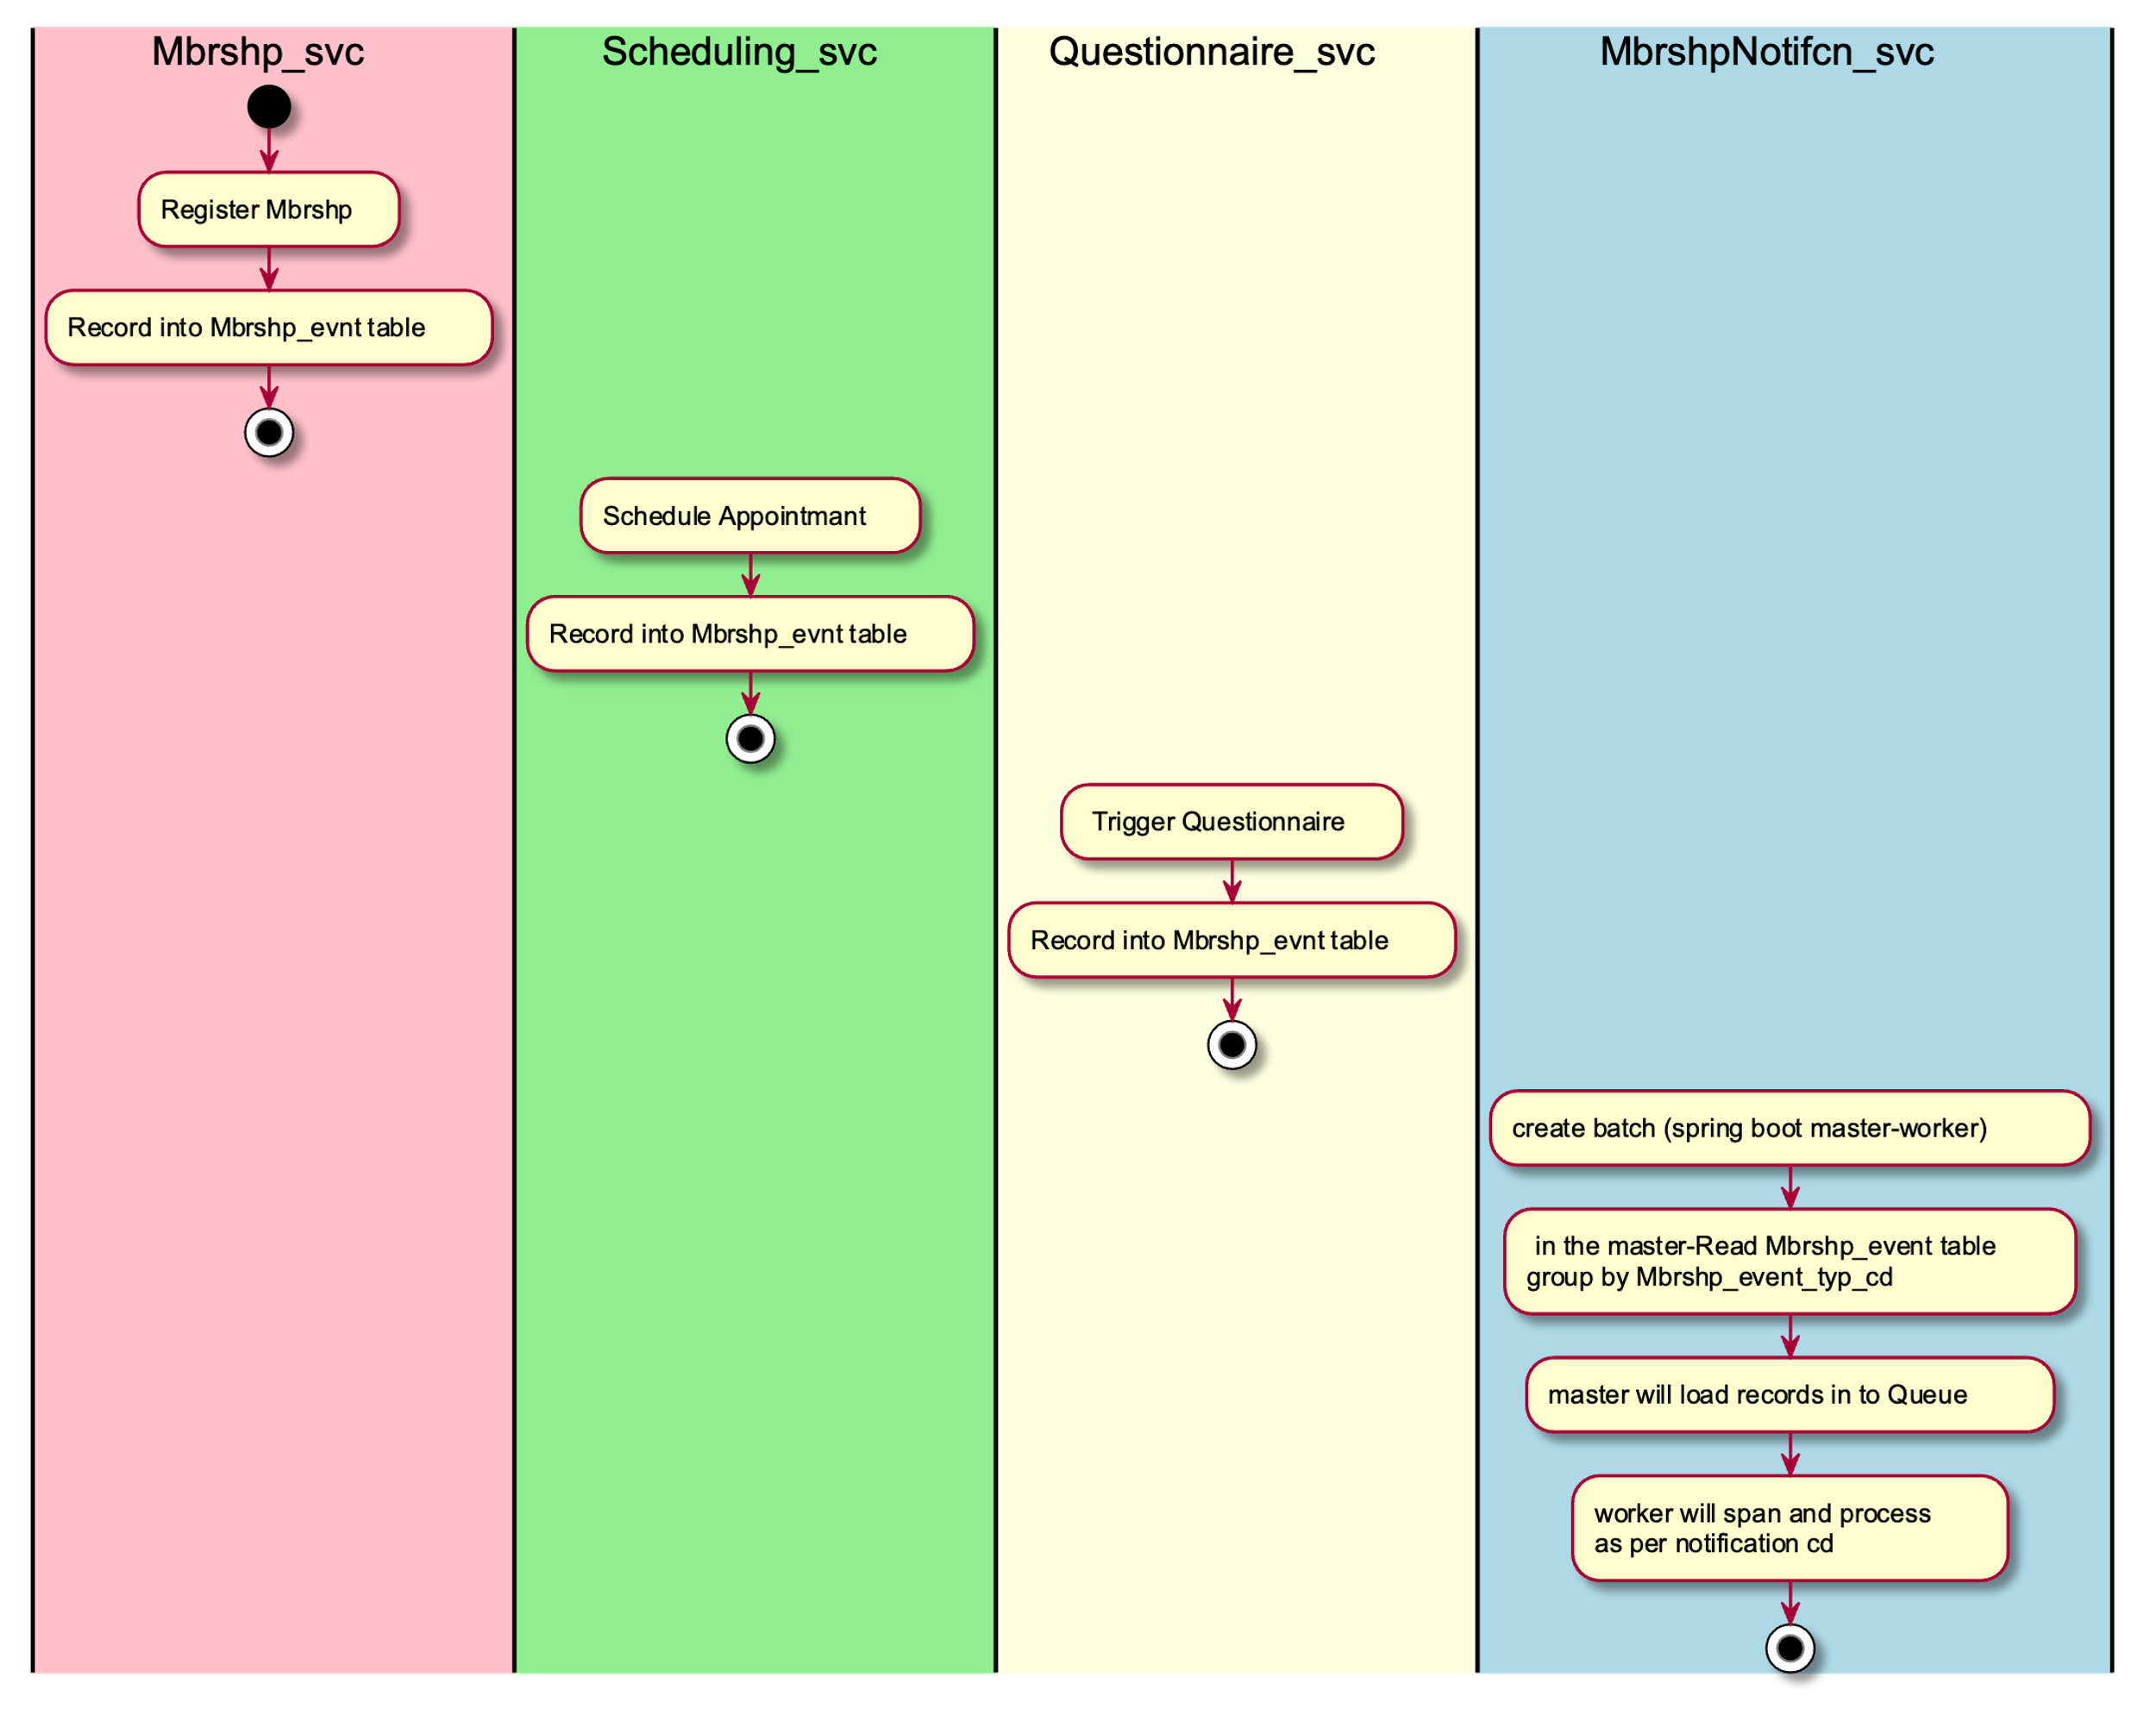

# Architecture Requirements

## Requirement Use cases -Diagram

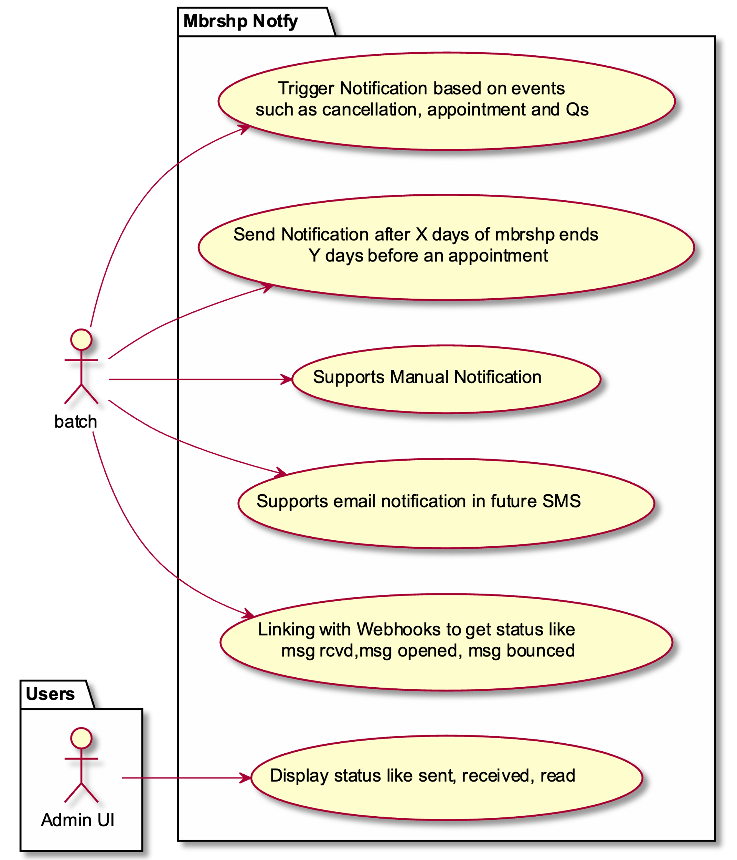

## Non- Functional Requirements

|  |  |
| --- | --- |
| SLA Hours | 24/7 (with Scheduled Maintenance window) |
| Maintenance window | Sunday 11:55 to 12:00 AM |
| Response Time | Based on non -prod (LP) dry run, need to update |

# Solution Design

## Logical Database Design

## Sequence Diagram

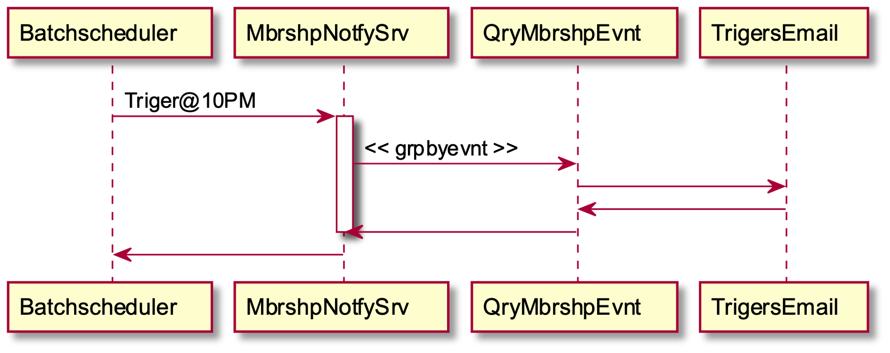

## Activity Diagram

